

The art of Debrieﬁng
Using critical thinking in youth work

26 May - 02 June
(excluding travel dates) Timisoara - Romania 2022

About the project
Description

Ever wondered what thinking strategy detective Sherlock Holmes, Columbo and Poirot used to solve their cases?
Ever wondered how Socrates or good journalists managed to ask such precise and effective questions? They all used the method of critical thinking.



It’s a true detective job!

Following the steps of the learning cycle we adopt these roles during the debrieﬁng
/discussion sessions when we sit down and discuss what happened during our theatre play, for example.
During these sessions consciousness and awareness emerges, but only if we know how to get it out from our learners; and in order to get it out effectively we have to master the technique of Sherlock and Socrates.
Moreover, it is mandatory that debrieﬁng sessions should be deep, challenging and engaging!

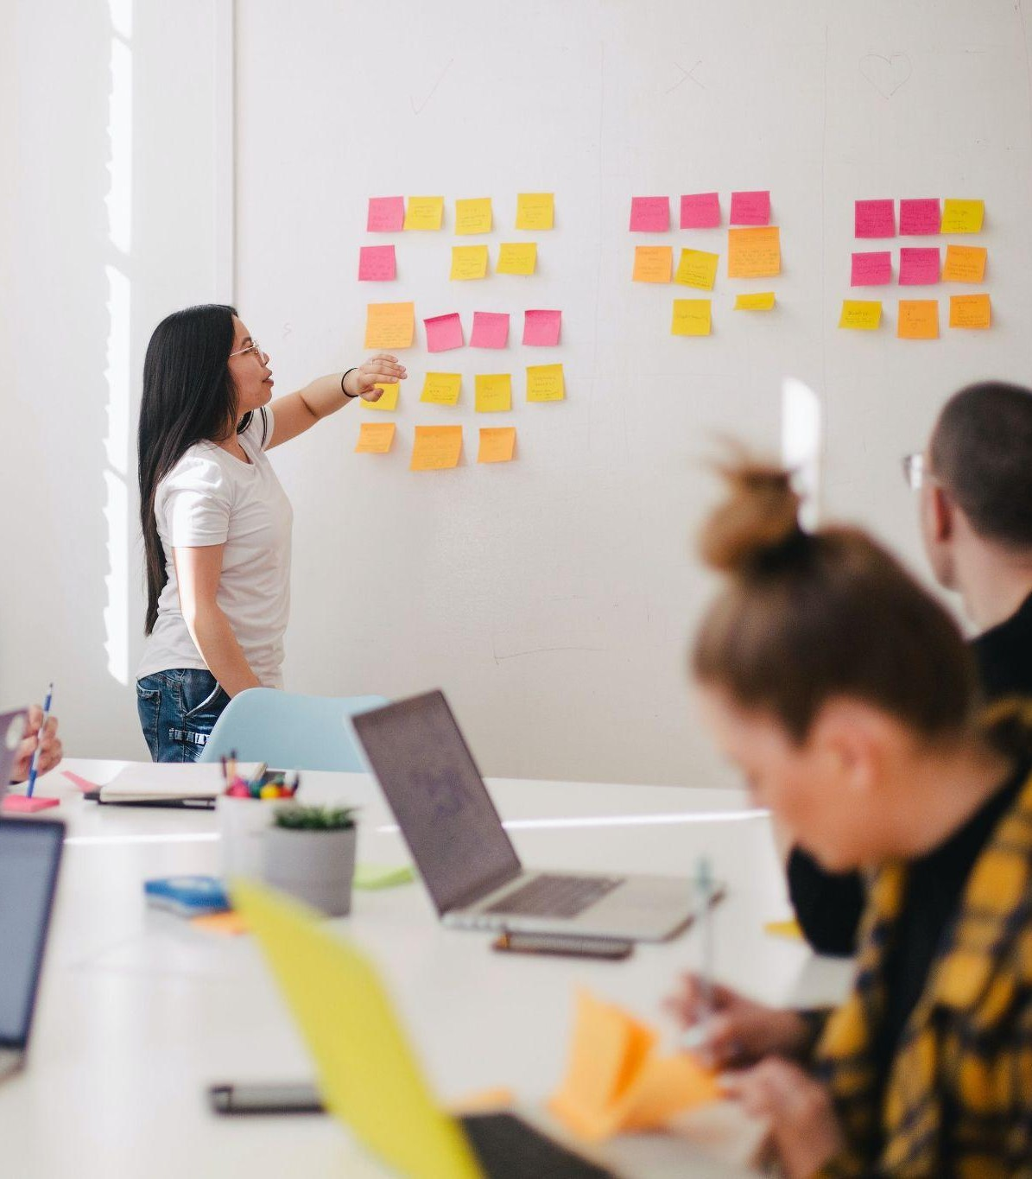

It’s mastered with practice & time

Most of the time we use the term critical thinking without knowing what it really is;
We think it’s just a different way of thinking than the majority, or “outside the box” thinking, or creative thinking and so on…
Of course critical thinking is also about that, in fact it is the foundation for all that.
But what the majority of people don’t know, is that critical thinking is a very precise technique and it is mastered with practice and time.

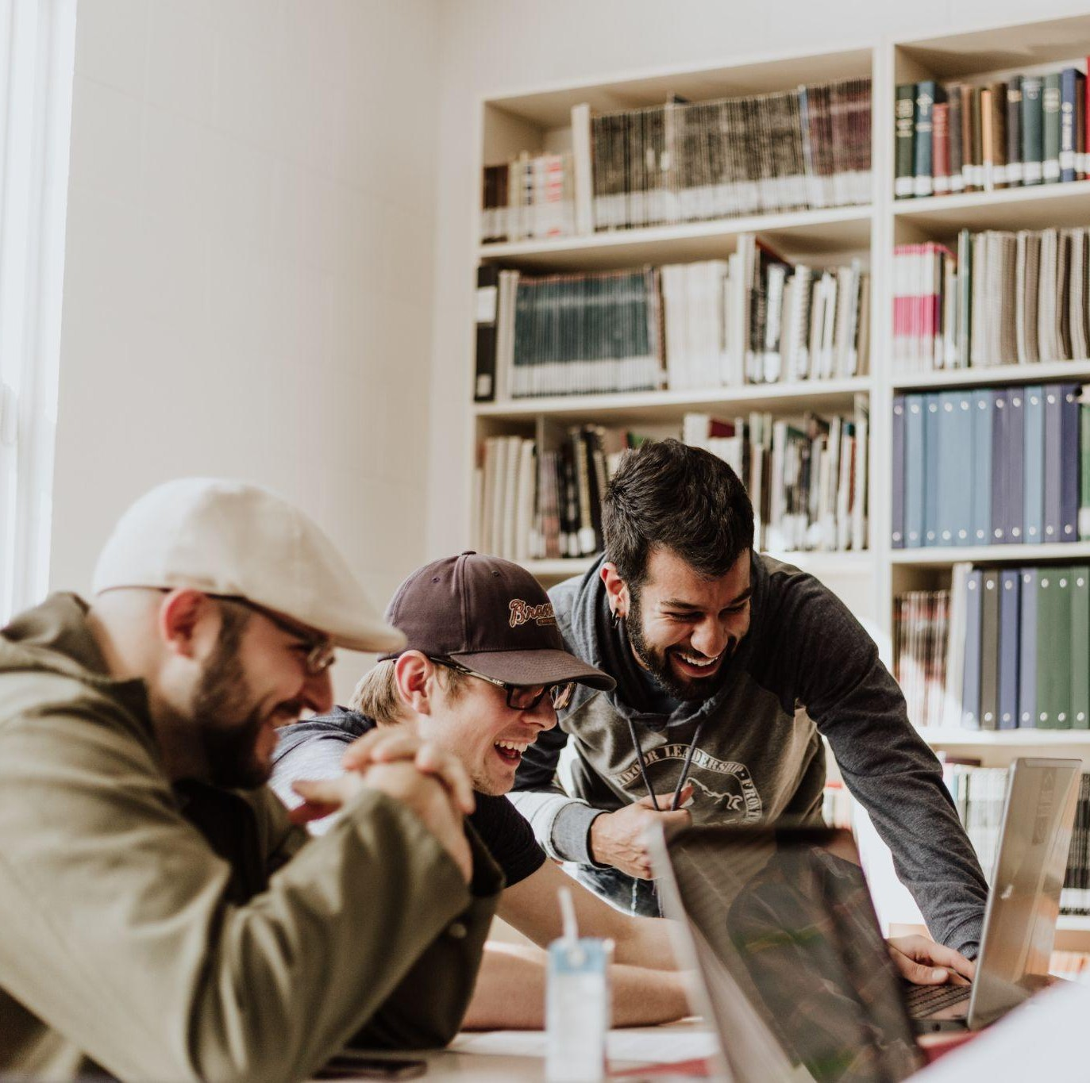

The aim of our Training Course project is to empower 24 Trainers and Youth Workers from 7 countries with CT skills to improve the quality of their educational methods and to integrate CT elements in their teaching/training/facilitating strategy in order to meet the learning needs of young people.

The Objectives

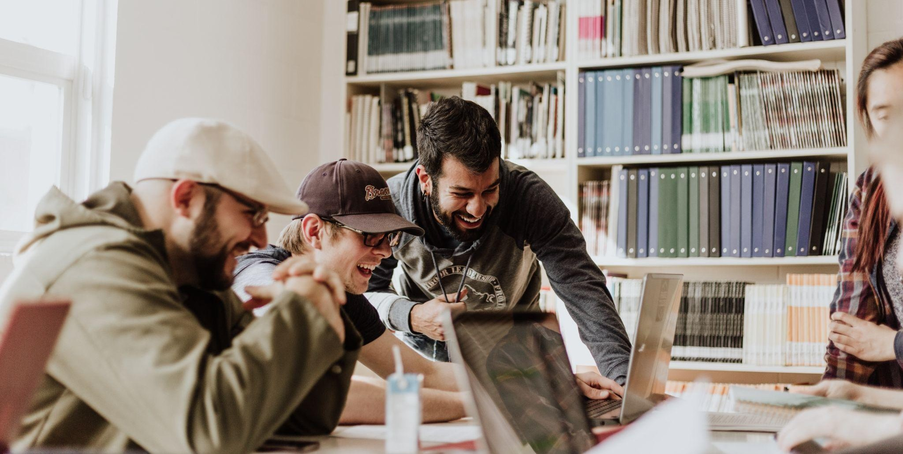
01
02
03

Develop and improve better critical thinking skills for 24 trainers and YW from 7 countries during a 8 day training course

Improve the quality of educational methods for 24 trainers and YW from 7 countries during a 8 day training course
Prepare 24 trainers and YW during a 8 days training course on how to use CT elements in the debrieﬁng/reﬂection /discussion sessions and into their teaching/training/ facilitating strategy in non-formal and informal learning.



The project proposes an innovative approach to facilitation of discussions/debrieﬁng using the critical thinking method from philosophy and philosophical practice.

NO BACKGROUND IN PHILOSOPHY IS NEEDED!



After this Training Course Youth workers and trainers will be able to:

- Master the art of questioning
- Master the art of interpretation
- Master the art of debrieﬁng
- Master the art of deduction
- Integrate critical thinking in their youth work
- Master the art of coaching: know how to approach young people’s negative attitudes



After this Training Course Youth workers and trainers will be able to:

- Analyze complex issues and problems that can arouse in a learning environment
- Recognize different points of view and assumptions from statements, questions etc.
- Master the art of coaching: know how to approach young people’s negative attitudes from a holistic perspective
- Improve the quality of their educational methods



This training course is useful for every tutor, trainer, youth worker.

It will be highly useful for those who approach topics and ﬁelds such as: human rights, personal development, hate-speech, democratic values, discrimination and racism, intercultural dialogue, active participation, journalism, designing programs, radicalization.

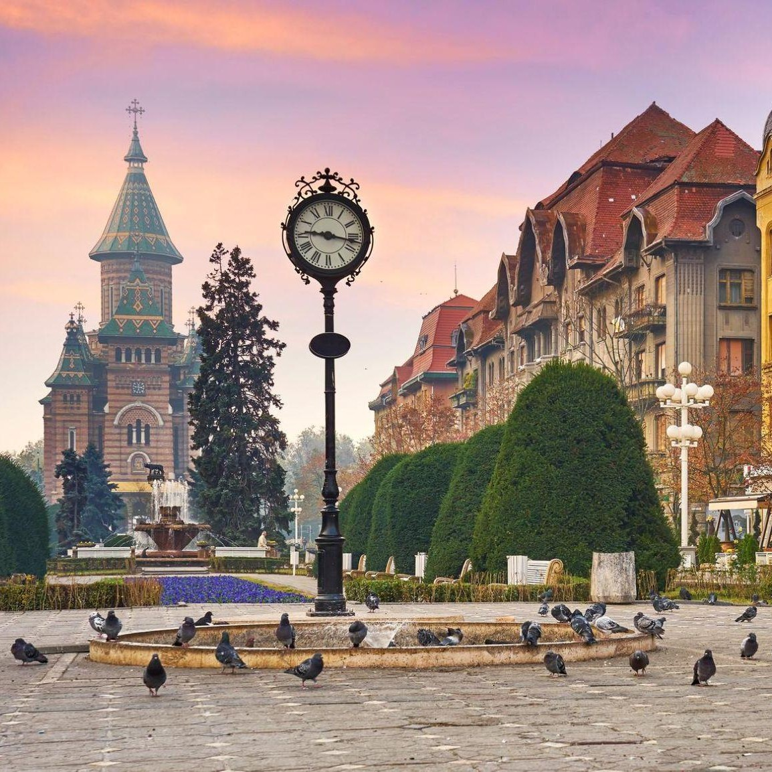

Host Country: Romania Host City: Timișoara
Partner Countries:

- Romania: 3 participants
- Italy: 4 participants
- Lithuania: 3 participants
- Spain: 3 participants
- Portugal: 3 participants
- Greece: 4 participants
- Poland: 4 participants



Participants Proﬁle
Between 24 - 45 years old, youth workers, trainers, teachers, minimum 1 year experience working with young people.

Dissemination Phase
Participants will have to do a series of educational workshops with the young people from their community back home.

Travel

Timișoara Aiport:
https:/ aerotim.ro

Nearest relevant airport to Timișoara is Budapest Airport:
https:/ www.bud.hu/en

Directions from the Airport to the Accommodation

TBA

From Budapest to Timișoara there is FlixBUS: HERE

Following the rules of the ERASMUS+ programme for this project are foreseen:

Country of origin | Country of destination | Distance Band in km | No. of participants | Travel grant per participant
Poland | Romania | 500 - 1999 | 4 | 275 euros
Greece | Romania | 500 - 1999 | 4 | 275 euros
Lithuania | Romania | 500 - 1999 | 3 | 275 euros
Spain | Romania | 500 - 1999 | 3 | 275 euros
Italy | Romania | 500 - 1999 | 4 | 275 euros
Portugal | Romania | 1999-20999 | 3 | 360 euros
Romania | Romania | 0 | 3 | 0 euros



The total amount covered is the max for the round trip for each participant; all the extra euros spent that overcome the max amount covered are in charge of the participants.

Example:

If you spend 300 euros on a round trip/transportation, you will be reimbursed only 275 euros. The rest of 25 euros will be covered by the participant.



Important:

Any ﬂight/bus/train or other means of transport won,t be reimbursed in case of participants miss the travel regardless of any reason.
According to the Erasmus Plus rules, the host organisation can only reimburse only the participants that participated in the Youth Exchange and those who signed the ofﬁcial list of participants during the exchange.
We can only reimburse a round trip back home. For example: If you live in Palermo, you have to show the tickets that proves that you arrived back in Palermo.

Registration form

https://forms.gle/TKUZc5YDjowunnH76


CONTACT US AT: asociatia.eda@outlook.com
Facebook: Victor Manciu
https:/ www.facebook.com/victor.manciu

Host Organization:
European Association for Adult Education - Romania

Partners:
DreamTeam - Greece

Fundacja "Zielony Slon" - Poland
AGENZIA DI PROMOZIONE INTEGRATA PER I CITTADINI IN EUROPA APICE - Italy

Associacio Cultura Creativa - Spain ASSOCIAÇÃO YOUTH LINE PORTUGAL - Portugal
Socialinis efektas, asociacija - Lithuania

